**LEBANESE AMERICAN UNIVERSITY**

**USAID – HIGHER EDUCATION SCHOLARSHIP PROGRAM**

**HES - Volunteering Program Verification Form**

This form is to be used to document volunteering hours. If a student volunteers for multiple organizations, a separate form must be used for each organization. **This form must be turned in by the 28th of each month, the latest.**

I certify that the scholar Omrao Maamo completed a total of 5 hours of service at InnovaThrive.

The hours were completed hours as per the below:

Hours # 0 (date) _2/12 – 6/12_ (initials of supervisor) __A.K.___

Hours # 5 (date) _9/12 – 13/12_ (initials of supervisor) __A.K.___

Hours # 0 date) _16/12 – 20/12 (initials of supervisor) __A.K.___

Hours # 0 date) _23/12 - 27/12 (initials of supervisor) __A.K.___

Brief description of the activities the scholar performed or participated in:

I conducted research on Artificial Intelligence and Its Role in Remote Team Collaboration, examining how AI technologies facilitate and enhance collaboration among remote teams.

Written feedback about the scholar’s performance:

Omrao exhibited strong research and analytical skills by exploring AI’s role in enhancing remote team collaboration, addressing both advantages and challenges.

Please rate the overall performance of the scholar at your organization:

|  |  |  |  |
| --- | --- | --- | --- |
|  | Mastery (5) | Proficient (3) | Emerging (1) |
| **Problem solver** | X |  |  |
| **Engaged & Committed** | X |  |  |
| **Open-minded & multicultural** | X |  |  |

Signature

& stamp

__________________________

_

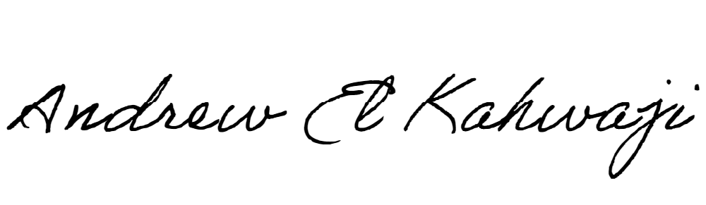

Printed Name _Andrew El Kahwaji_

Date __26/12/2024___

Email __andrew.lifesculptor.coo@gmail.com __

Phone __+961 71 914 378__